Year 5/6 Long Term Overview
Persuade Inform Entertain Discuss
Autumn 1 | Autumn 2 | Spring 1 | Spring 2 | Summer 1 | Summer 2
Learning Journey | Learning Journey | Learning Journey | Learning Journey | Learning Journey | Learning Journey
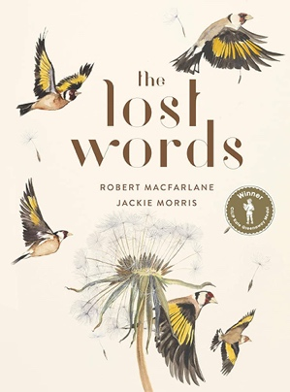  Text: The Lost Words  Purpose: To entertain  Audience: Reader of ‘The Lost Words’  Form: Poetry | Text: Beowulf  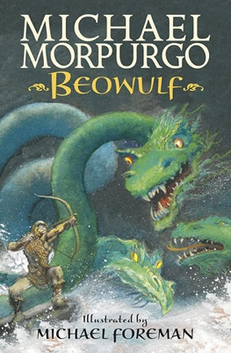  Purpose: To entertain  Audience: Year 5/6  Form: Heroic legend narrative  How The Grinch Stole Christmas  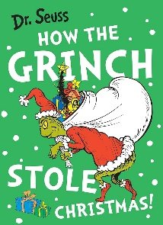  Purpose: To inform  Audience: someone who doesn’t like Christmas  Form: instructions to steal Christmas | Text: Rain Player  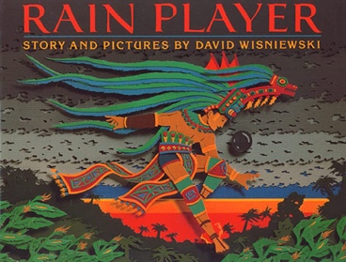  Purpose: To inform  Audience: Reader interested in finding out more about The Maya  Form: Analytical essay | Titanic  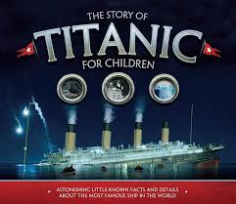  Many outcomes to prepare for KS2 judgements and moderation | Text: Windrush Child  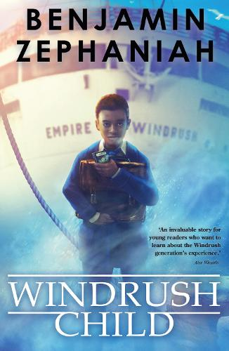  Purpose: To persuade  Audience: Local council  Form: Written pitch | Text: Anne Frank  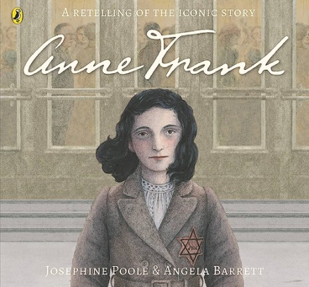  Purpose: To discuss  Audience: Readers interested in Anne Frank’s diary  Form: Opinion piece
Preparing poems and plays to read aloud and to perform, showing understanding through intonation, tone and volume  Writing (Composition)  Use figurative language in a range of writing  Brackets, dashes or commas to indicate parenthesis  Using modal verbs or adverbs to indicate degrees of possibility | Grammar and punctuation:  Relative clauses beginning with who, which, where, when, whose, that, or an omitted relative pronoun  Indicating degrees of possibility using adverbs [for example, perhaps, surely] or modal verbs [for example, might, should, will, must]  Linking ideas across paragraphs using adverbials of time [for example, later], place [for example, nearby] and number [for example, secondly] or tense choices [for example, he had seen her before]  Brackets, dashes or commas to indicate parenthesis  Use of commas to clarify meaning or avoid ambiguity  Use of expanded noun phrases to convey complicated information concisely  Devices to build cohesion within a paragraph [for example, then, after that, this, firstly]  How words are related by meaning as synonyms and antonyms [for example, big, large, little] (Y6)  The difference between structures typical of informal speech and structures appropriate for formal speech and writing [for example the use of subjunctive forms such as If I were or Were they to come in some very formal writing and speech] (Y6)  Writing (Composition)  In writing narratives, considering how authors have developed characters and settings in what pupils have read, listened to or seen performed  In narratives, describing settings, characters and atmosphere and integrating dialogue to convey character and advance the action | Grammar and punctuation:  Use of inverted commas and other punctuation to indicate direct speech  Recognising vocabulary and structures that are appropriate for formal speech and writing, including subjunctive forms  Using modal verbs or adverbs to indicate degrees of possibility  Linking ideas across paragraphs using adverbials of time [for example, later]  The difference between vocabulary typical of informal speech and vocabulary appropriate for formal speech and writing [for example, find out – discover; ask for – request; go in – enter]  The difference between structures typical of informal speech and structures appropriate for formal speech and writing [for example, the use of question tags: He’s your friend, isn’t he?]  Linking ideas across paragraphs using a wider range of cohesive devices: repetition of a word or phrase, grammatical connections [for example, the use of adverbials such as on the other hand, in contrast, or as a consequence], and ellipsis  Layout devices [for example, headings, sub-headings, columns, bullets, or tables, to structure text]  Use of the colon to introduce a list and use of semi-colons within lists  Use of the passive to affect the presentation of information in a sentence [for example, I broke the window in the greenhouse versus The window in the greenhouse was broken (by me)]  Writing (Composition)  In narratives, describing settings, characters and atmosphere and integrating dialogue to convey character and advance the action  Using further organisational and presentational devices to structure text and to guide the reader [for example, headings, bullet points, underlining] | Grammar and punctuation:  Use of inverted commas and other punctuation to indicate direct speech  Use of the present perfect and progressive forms of verbs instead of the simple past [for example, He has gone out to play contrasted with He went out to play]  Verb prefixes [for example, dis–, de–, mis–, over– and re–]  Relative clauses beginning with who, which, where, when, whose, that, or an omitted relative pronoun  Indicating degrees of possibility using adverbs [for example, perhaps, surely] or modal verbs [for example, might, should, will, must]  Brackets, dashes or commas to indicate parenthesis  Use of the passive to affect the presentation of information in a sentence [for example, I broke the window in the greenhouse versus The window in the greenhouse was broken (by me)]  The difference between structures typical of informal speech and structures appropriate for formal speech and writing [for example, the use of question tags: He’s your friend, isn’t he?, or the use of subjunctive forms such as If I were or Were they to come in some very formal writing and speech]  Layout devices [for example, headings, sub-headings, columns, bullets, or tables, to structure text]  Use of the semi-colon, colon and dash to mark the boundary between independent clauses [for example, It’s raining; I’m fed up]  Writing (Composition)  Ensuring correct subject and verb agreement when using singular and plural, distinguishing between the language of speech and writing and choosing the appropriate register | Grammar and punctuation:  Recognising vocabulary and structures that are appropriate for formal speech and writing, including subjunctive forms  Using expanded noun phrases to convey complicated information concisely  Using modal verbs or adverbs to indicate degrees of possibility  Using relative clauses beginning with who, which, where, when, whose, that or with an implied (i.e. omitted) relative pronoun  Using commas to clarify meaning or avoid ambiguity in writing  Using a colon to introduce a list  Punctuating bullet points consistently  Writing (Composition)  Using further organisational and presentational devices to structure text and to guide the reader [for example, headings, bullet points, underlining] | Grammar and punctuation:  Indicating degrees of possibility using adverbs [for example, perhaps, surely] or modal verbs [for example, might, should, will, must]  Devices to build cohesion within a paragraph [for example, then, after that, this, firstly]  Linking ideas across paragraphs using adverbials of time [for example, later], place [for example, nearby] and number [for example, secondly] or tense choices [for example, he had seen her before]  How words are related by meaning as synonyms and antonyms  The difference between structures typical of informal speech and structures appropriate for formal speech and writing [for example, the use of question tags: He’s your friend, isn’t he?, or the use of subjunctive forms such as If I were or Were they to come in some very formal writing and speech]  Writing (Composition)  In narratives, describing settings, characters and atmosphere and integrating dialogue to convey character and advance the action
Ongoing statements:

Writing Transcription (Spelling and Handwriting)
- Use further prefixes and suffixes and understand the guidance for adding them
- Use knowledge of morphology and etymology in spelling and understand that the spelling of some words needs to be learnt specifically, as listed in English Appendix 1
- Use dictionaries to check the spelling and meaning of words
- Use the first three or four letters of a word to check spelling, meaning or both of these in a dictionary
- Use a thesaurus

Writing Composition
- Ensure the consistent and correct use of tense throughout a piece of writing
- Use a wide range of devices to build cohesion within and across paragraphs
- Plan their writing by: - Identifying the audience for and purpose of the writing, selecting the appropriate form and using other similar writing as models for their own
- Draft and write by: - Selecting appropriate grammar and vocabulary, understanding how such choices can change and enhance meaning
- Evaluate and edit by: - Assessing the effectiveness of their own and others’ writing - Proposing changes to vocabulary, grammar and punctuation to enhance effects and clarify meaning - Proof-reading for spelling and punctuation errors
- Précising longer passages
Guided Reading | Guided Reading | Guided Reading | Guided Reading | Guided Reading | Guided Reading
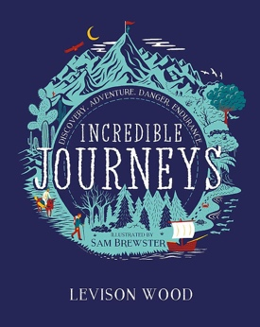  Text: Incredible Journeys | Text: Sir Gawain and the Green Knight  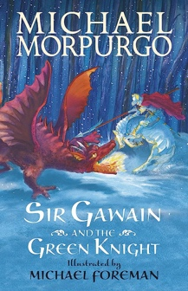 | 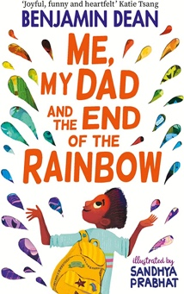  Text: Me, My Dad and the End of the Rainbow | Text: Politics for Beginners  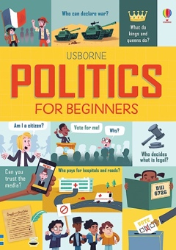 | Text: Black and British  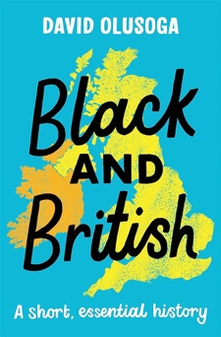 | Text: Letters from the Lighthouse  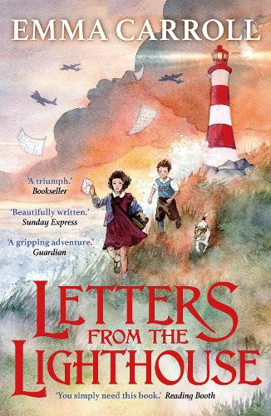
drawing inferences such as inferring characters’ feelings, thoughts and motives from their actions, and justifying inferences with evidence  predicting what might happen from details stated and implied  summarising the main ideas drawn from more than one paragraph, identifying key details that support the main ideas  identifying how language, structure and presentation contribute to meaning  discuss and evaluate how author’s use language, including figurative language, considering the impact on the reader  distinguish between statements of fact and opinion  retrieve, record and present information from non-fiction | drawing inferences such as inferring characters’ feelings, thoughts and motives from their actions, and justifying inferences with evidence  predicting what might happen from details stated and implied  summarising the main ideas drawn from more than 1 paragraph, identifying key details that support the main ideas  identifying how language, structure and presentation contribute to meaning  discuss and evaluate how author’s use language, including figurative language, considering the impact on the reader  retrieve, record and present information from non-fiction | drawing inferences such as inferring characters’ feelings, thoughts and motives from their actions, and justifying inferences with evidence  predicting what might happen from details stated and implied  summarising the main ideas drawn from more than 1 paragraph, identifying key details that support the main ideas  identifying how language, structure and presentation contribute to meaning  discuss and evaluate how author’s use language, including figurative language, considering the impact on the reader  retrieve, record and present information from non-fiction | drawing inferences such as inferring characters’ feelings, thoughts and motives from their actions, and justifying inferences with evidence  predicting what might happen from details stated and implied  summarising the main ideas drawn from more than 1 paragraph, identifying key details that support the main ideas  identifying how language, structure and presentation contribute to meaning  discuss and evaluate how author’s use language, including figurative language, considering the impact on the reader  retrieve, record and present information from non-fiction | drawing inferences such as inferring characters’ feelings, thoughts and motives from their actions, and justifying inferences with evidence  predicting what might happen from details stated and implied  summarising the main ideas drawn from more than one paragraph, identifying key details that support the main ideas  identifying how language, structure and presentation contribute to meaning  discuss and evaluate how author’s use language, including figurative language, considering the impact on the reader  distinguish between statements of fact and opinion  retrieve, record and present information from non-fiction | preparing poems and plays to read aloud and to perform, showing understanding through intonation, tone and volume so that the meaning is clear to an audience  drawing inferences such as inferring characters’ feelings, thoughts and motives from their actions, and justifying inferences with evidence  predicting what might happen from details stated and implied  summarising the main ideas drawn from more than one paragraph, identifying key details that support the main ideas  identifying how language, structure and presentation contribute to meaning  Discuss and evaluate how author’s use language, including figurative language, considering the impact on the reader  Distinguish between statements of fact and opinion  Retrieve, record and present information from non-fiction
Ongoing statements

Apply their growing knowledge of root words, prefixes and suffixes (morphology and etymology), as listed in English appendix 1, both to read aloud and to understand the meaning of new words that they meet

Checking that the book makes sense to them, discussing their understanding and exploring the meaning of words in context

Asking questions to improve their understanding

Explain and discuss their understanding of what they have read, including through formal presentations and debates, maintaining a focus on the topic and using notes where necessary

Provide reasoned justifications for their views

Continuing to read and discuss an increasingly wide range of fiction, poetry, plays, non-fiction and reference books or textbooks

Participate in discussions about books that are read to them and those they can read for themselves, building on their own and others’ ideas and challenging views courteously

Increasing their familiarity with a wide range of books, including myths, legends and traditional stories, modern fiction, fiction from our literary heritage, and books from other cultures and traditions

Identifying and discussing themes and conventions in and across a wide range of writing

Making comparisons within and across books

